11/17/2021

Saif, Arsalan

EE 310 Fall 2021

Op-Amp Design Project

Rocket Probe Signal Conditioning and Interfacing Circuits

**INTRODUCTION**

In this project, we focus on linear circuit applications assuming that the op amp is an ideal device, and also on its use as a comparator (a nonlinear circuit). The use of Op-amps in linear circuits, such as analog signal conditioning and interface, is important. Often, when designing linear circuits, we consider the Op-amp to behave as an ideal device. Once the necessary circuit functions are envisioned, the design process becomes one of designing the various stages to satisfy the specified problem. Op amps have the advantage that we can cascade stages with relatively large input impedances and small output impedances, so they are not interacting with each other. The current requirements of external components (e.g., resistors and capacitors) must be taken into account when choosing their values to ensure that they are not too large for the op amps. Once we have made sure that our design specifications are satisfied, at least in an ideal sense, we need to consider the non-ideal (practical) characteristics of the op amp and identify any potential problems that might arise.

The particular application to be considered involves the task of measuring the current of charge collected by a rocket probe, converting the current to a voltage, removing an unwanted common-mode signal (the bias voltage applied to the probe for charge collection), and finally doing the necessary signal processing (voltage scaling and shifting) to ensure compatibility with the input to a telemetry system (typically, a PCM encoder). It also is desirable to know the probe collection voltage's polarity since we expect positive charge collection to result when the probe has a negative bias voltage, and vice versa.

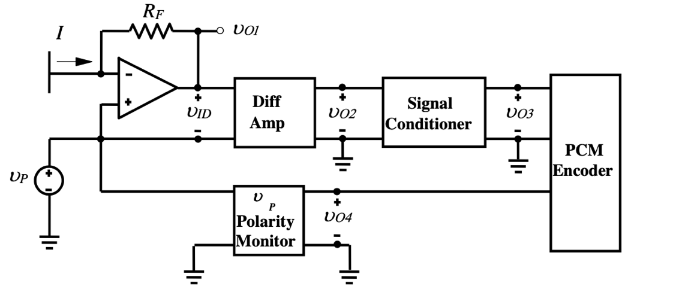

Figure 1.1 Illustrates the diagram of Probe Signal Conditioning and Interfacing Circuits

|  |  |  |  |  |  |  |  |
| --- | --- | --- | --- | --- | --- | --- | --- |
| Vin (V) | I (uA) | V01’ (V) | V01 (V) | V02 (V) | V03 (V) | Vp (V) | V04 (V) |
| 5 | 10 | -2 | -12 -> 8 | -2 | 5 | Any > 0 | 5 |
| 0 | 0 | 0 | -10 -> 10 | 0 | 2.5 | Any <= 0 | 0 |
| -5 | -10 | 2 | -8 -> 12 | 2 | 0 |  |  |

Table 1.1 Displays the desired outputs with specifications and constraints

**CIRCUIT DESIGN AND SUPPORTING ANALYSIS**

**Current to Voltage Amplifier**

Gain = -Rf/Ri

-2V/5V= -Rf/Ri -> 2Ri= 5Rf

Rf=200k ohms

Ri= 500k ohms

5V/500k ohms = 10 uA

For R2: Vo=(1+R2/R1) Rb/Ra+rb Vi1 + (1+R2/R1) Ra/Rb+Ra Vi2

R2 = R1= Ra=Rb -> Vo = Vi1+Vi2

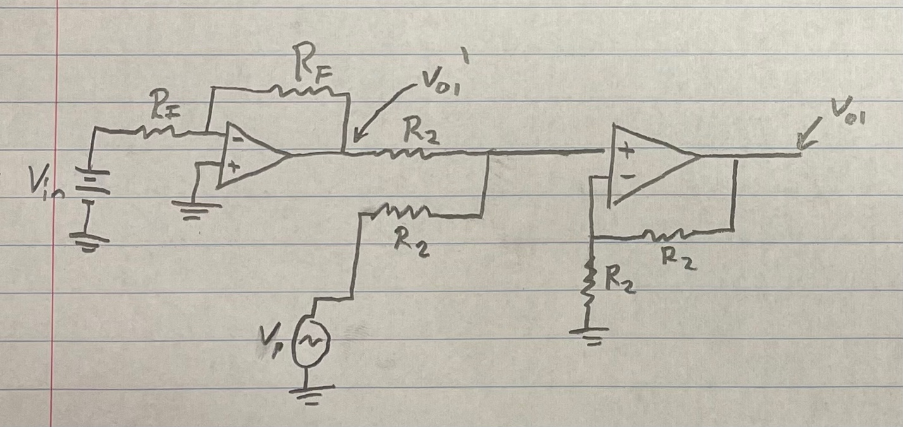

Figure 1.2 Displays the schematic of the current to voltage amplifier

The schematic of the current to voltage amplifier includes two op-amps. The circuit can be described as having a gain as calculated above. Since the output amplitude is equal to the input amplitude multiplied. Therefore, it’s a different type of gain because the output signal and the input signal have different units. Op-amp based transimpedance amplifiers such as above take in a current input and output voltage that involves amplification. In this case, the current relates to voltage through the resistor in the feedback loop.

**Difference Amplifier**

Vo= -R2/R1 * Vi1 + (1+R2/R1) R4/R3+R4 * Vi2

R2 = R4, R1=R3

Vo=R2/R1 (Vi2-Vi1)

R2=R1

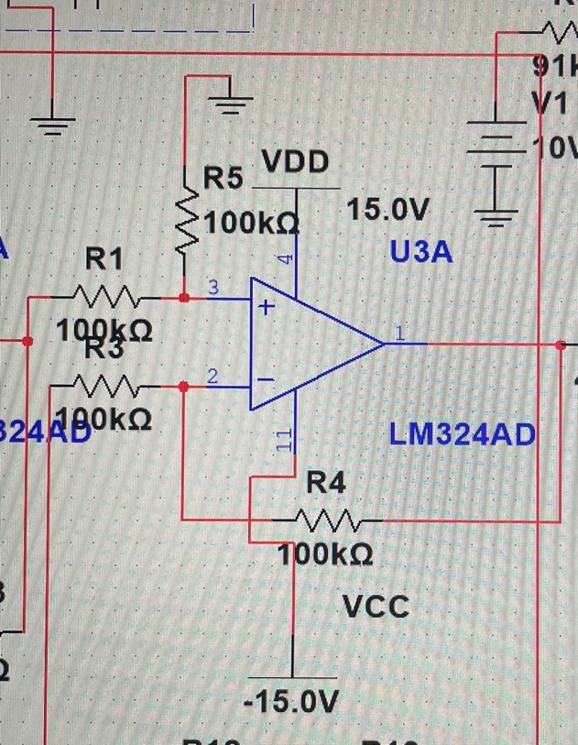

Figure 1.3 Exclusively illustrates the schematic of the Difference Amplifier from multisim.

The function of the difference amplifier is to take the difference in signals applied at the input. A difference amplifier is useful in cases where there is noise at both inputs which we would not want to amplify so we only amplify what is unique between both signals. The Differential Amplifier circuit is a very useful op-amp circuit and by adding more resistors in parallel with the input resistors R1 and R3, the resultant circuit can be made to either “Add” or “Subtract” the voltages applied to their respective inputs. We use superposition to solve for the output voltage. In this case, all the resistors are all of the same ohmic value, that is: R1 = R2 = R3 = R4 then the circuit will become a Unity Gain Differential Amplifier and the voltage gain of the amplifier will be exactly one or unity

**Signal Conditioner**

10V DC input:

Vo3 = -Rs/R3 Vo2 +(1+Rs/R3) R2/R1+R2 *10V

Vo3 = -5/4Vo2+ 2.5

-5/4 = -Rs/R3 -> Rs = 50k ohms R3 = 40k ohms

2.5 = (1+5/4) R2/R1+R2 *10

1/9 = R2/R1+R2 -> R2 = 10k ohms R1 = 91k ohms

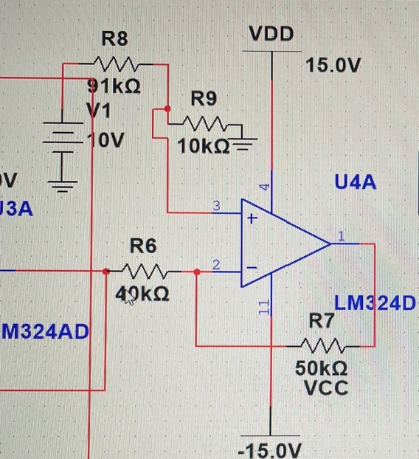

Figure 1.4a) Exclusively shows the schematic of the Signal Conditioner from multisim.

In this case, the circuit manipulates a signal in a way that prepares it for the next stage of processing. The signal conditioner has filtering in a way that it prevents the passage of high voltages into the control-side loop by galvanic isolation. It can use certain properties to make sensor output suitable for processing after conditioning. Isolation is a process of converting filtered & amplified signal to other form such as frequency so to pass the signal to measurement device without a physical connection. We use this test circuit to build our polarity monitor subsystem as it uses key information for this. The calculation above shows the values determined for resistors and Vo3.

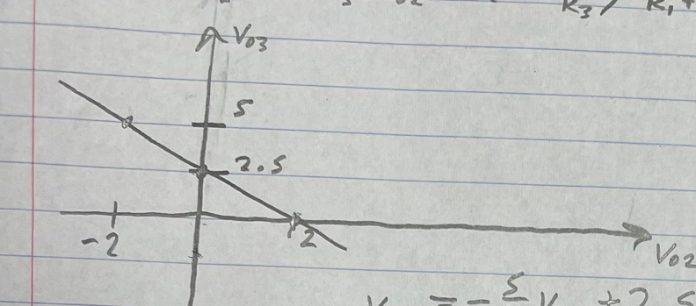

Figure 1.4b) Shows the linear relationship between Vo3 and Vo2.

**Polarity Monitor Subsystem**

Vo4= -1/6 Vp + 2.5

Vo4= -R9/R10 Vp’ + (1+R9/R10) R8/R7+R8 *10V

R9= 10k ohms, R10= 60k ohms

2.5=70/6 * R8/R7+R8

R8 = 10k ohms, R7 = 36k ohms

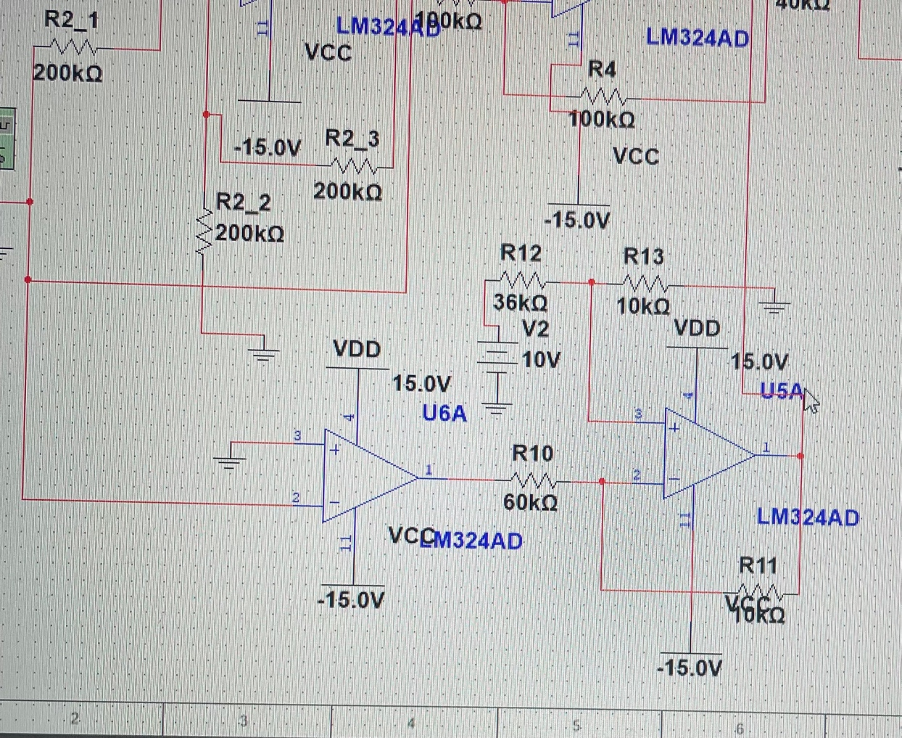

Figure 1.5a) Exclusively displays the schematic of the polarity monitor from multisim.

The polarity monitor uses a comparator and the use of two op-amps for its functionality. It uses information from signal conditioner. We use KVL to find Vo4 value. Also find the resistor values. The polarity monitor could be build separately as it uses information from the initial circuit but in this case we the signal conditioner as an initial stage for this circuit.

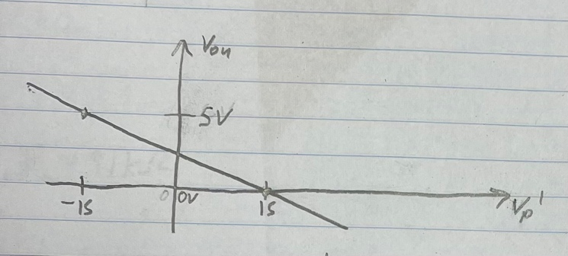

Figure 1.5b) Shows the linear relationship between Vo4 and Vp’.

**DATA**

|  |  |  |  |  |  |  |  |
| --- | --- | --- | --- | --- | --- | --- | --- |
| Vin (V) | I (uA) | V01’ (V) | V01 (V) | V02 (V) | V03 (V) | Vp (V) | V04 (V) |
| 5 | 10 | -1.958 | -11.5 -> 8.25 | -1.75 | 5.25 | 10.25 | 5 |
| 0 | 0 | -325.5u | -9.25 -> 10 | 250m | 2.5 | -9.5 | 250m |
| -5 | -10 | 2.250 | -7.5 -> 12.25 | 2.25 | 0 |  |  |

Table 1.2 Shows the measured values for output with specifications and constraints

It is important to mention that for the graphs below show that Channel 1 was used to measure the signal as Vin was connected to the DC power supply and we changed the voltage every time to measure values at those specific voltages.

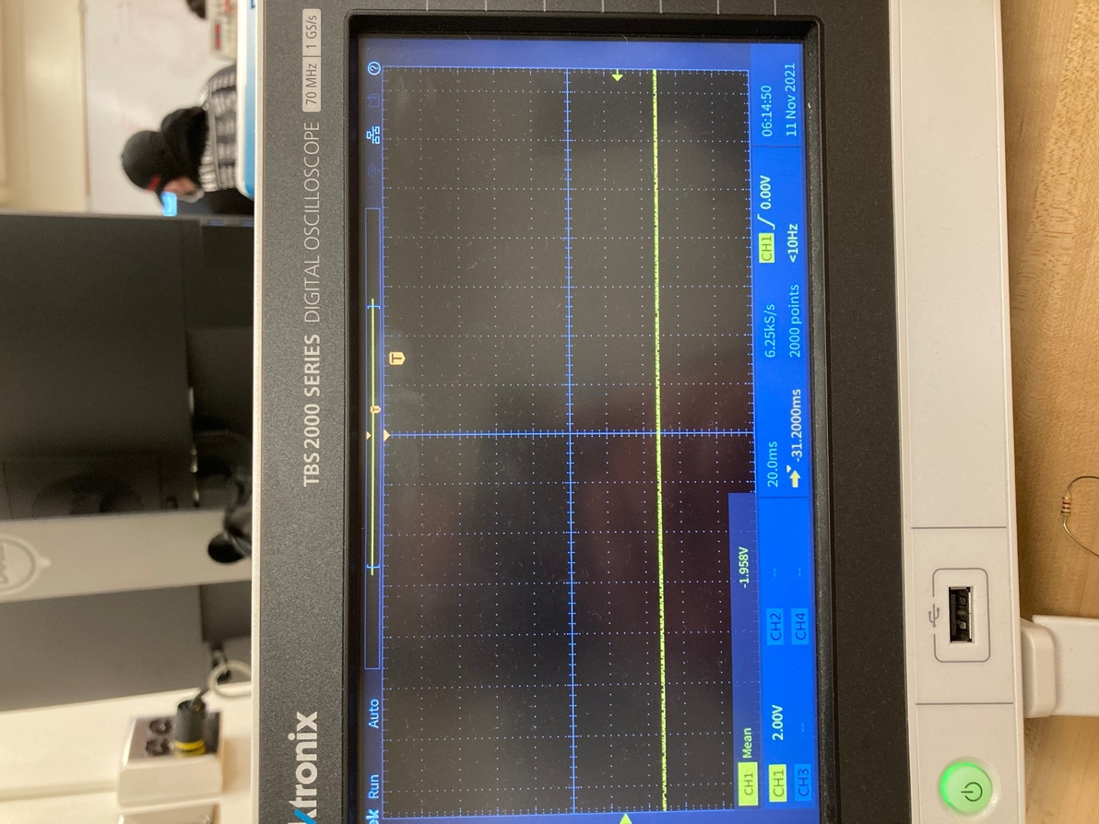

Figure 1.6 Portrays the scope for V01’ at Vin=5V

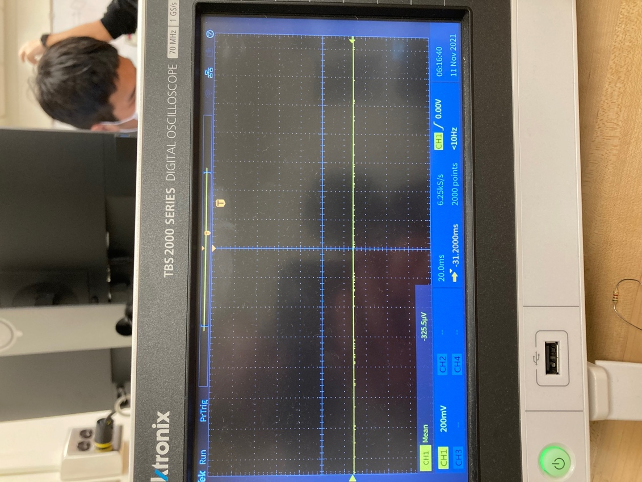

Figure 1.7 Illustrates the scope for V01’ at Vin=0V

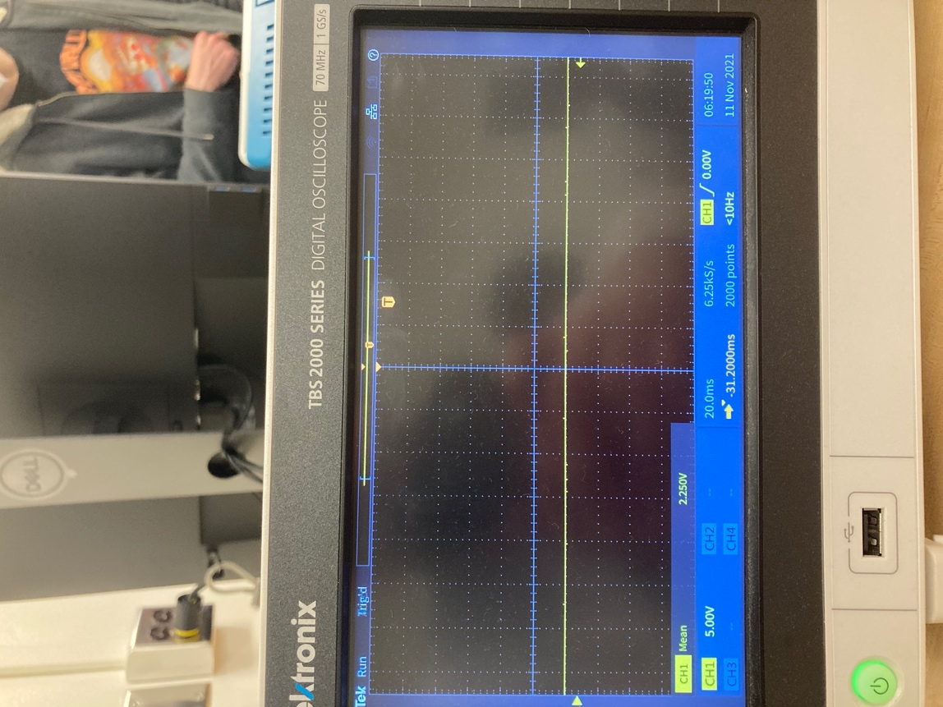

Figure 1.8 Shows the scope for V01’ at Vin=-5V

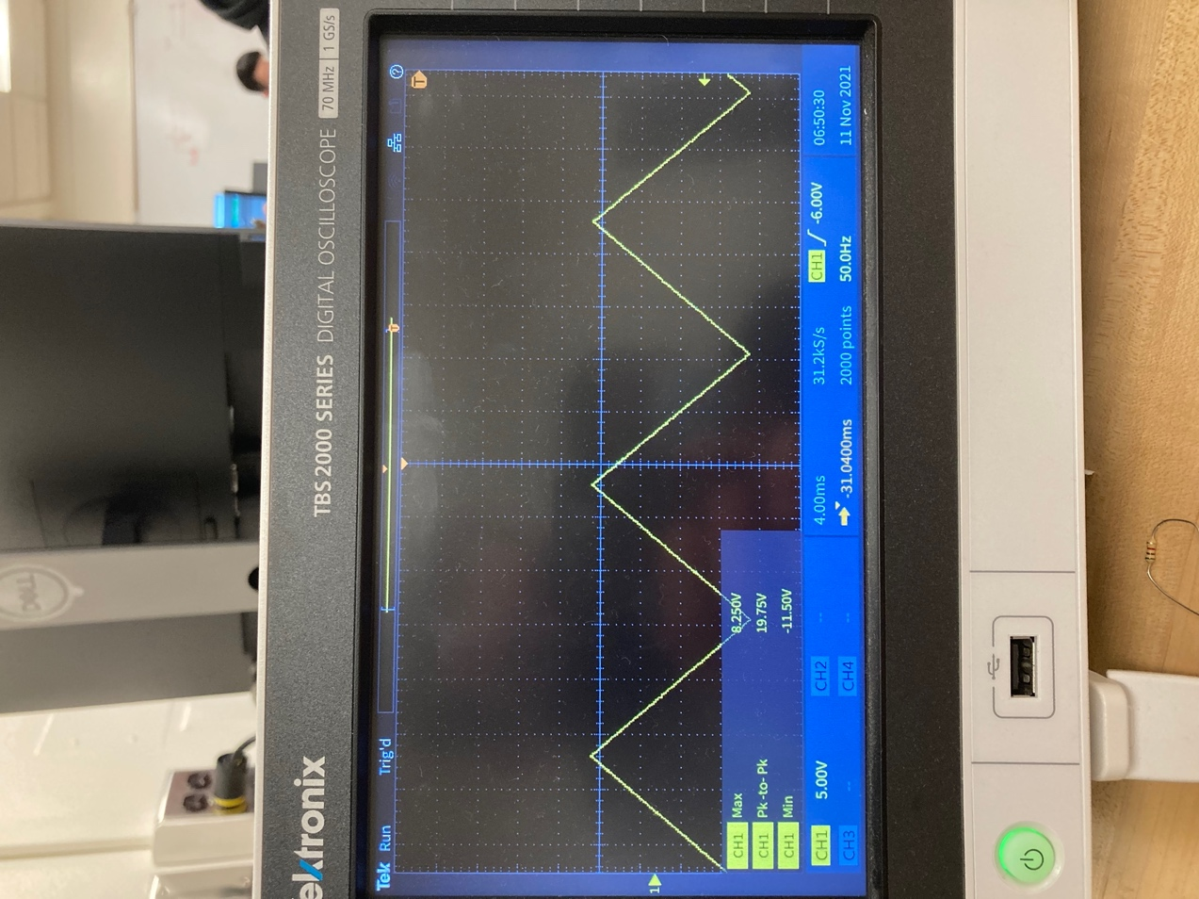

Figure 1.9 Displays the scope for V01 at Vin=5V

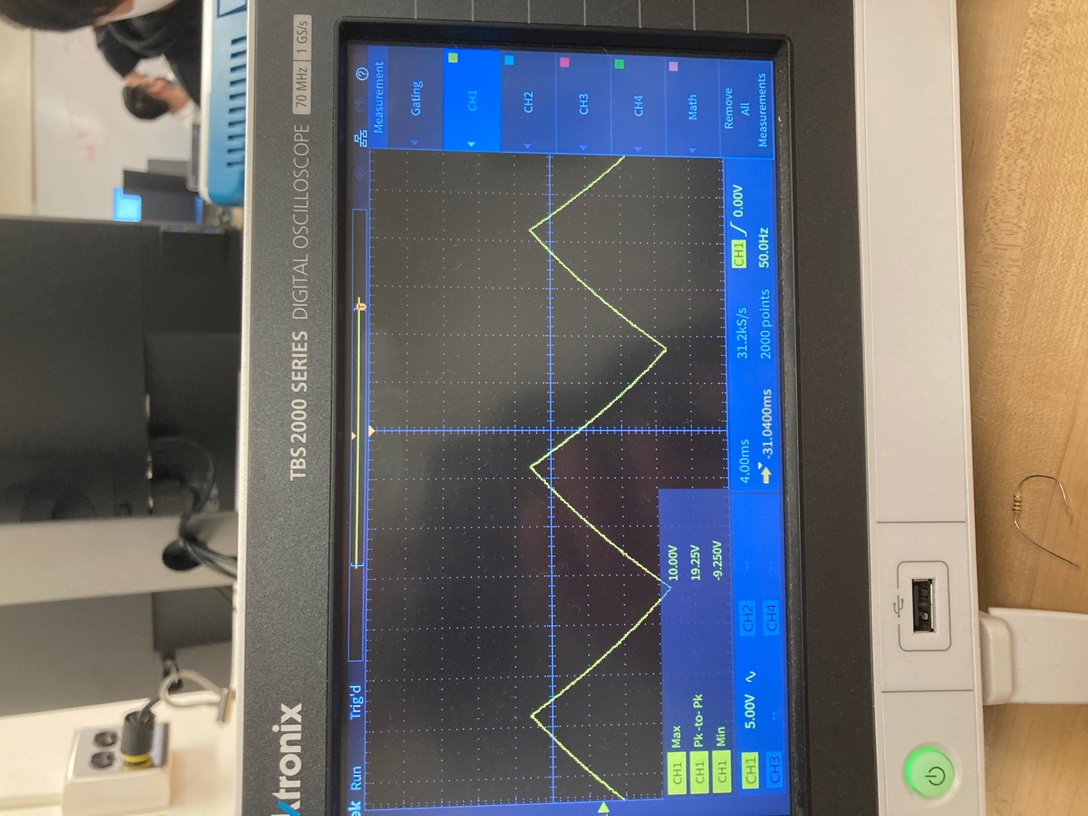

Figure 1.10 Illustrates the scope for V01 at Vin=0V

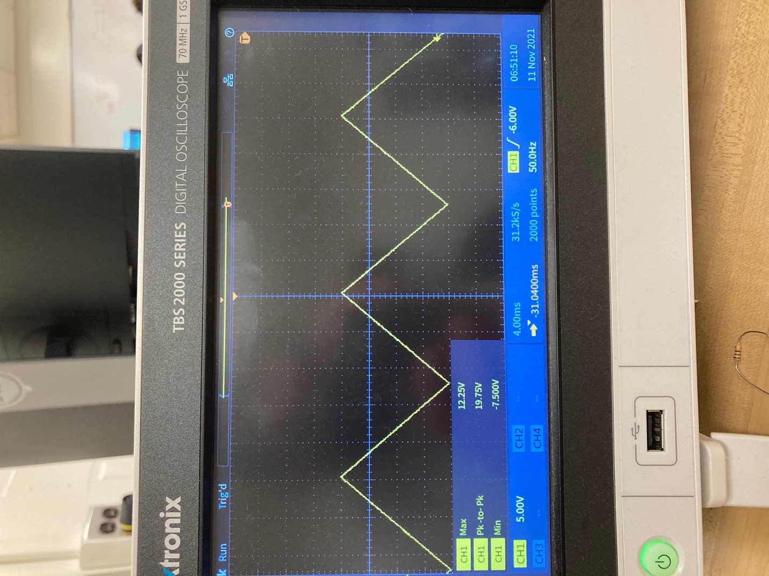

Figure 1.11 Shows the scope for V01 at Vin=-5V

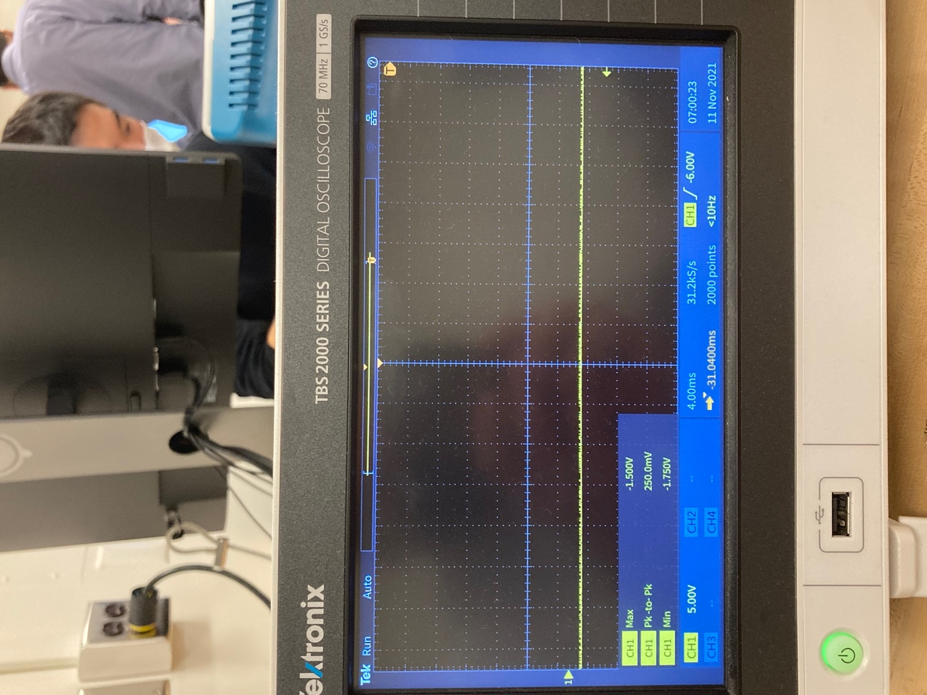

Figure 1.12 Displays the scope for V02 at Vin=5V

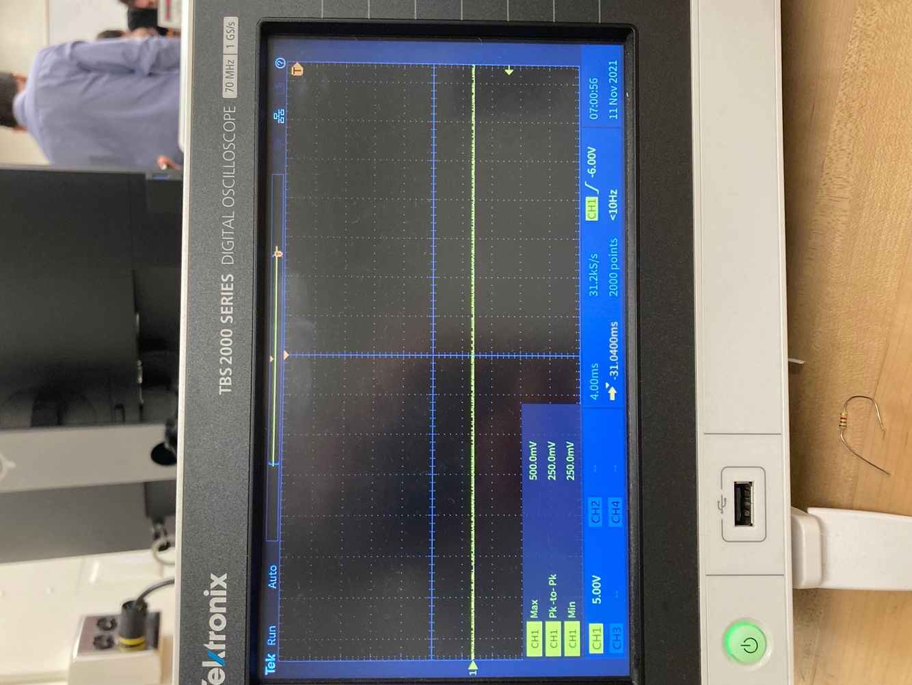

Figure 1.13 Portrays the scope for V02 at Vin=0V

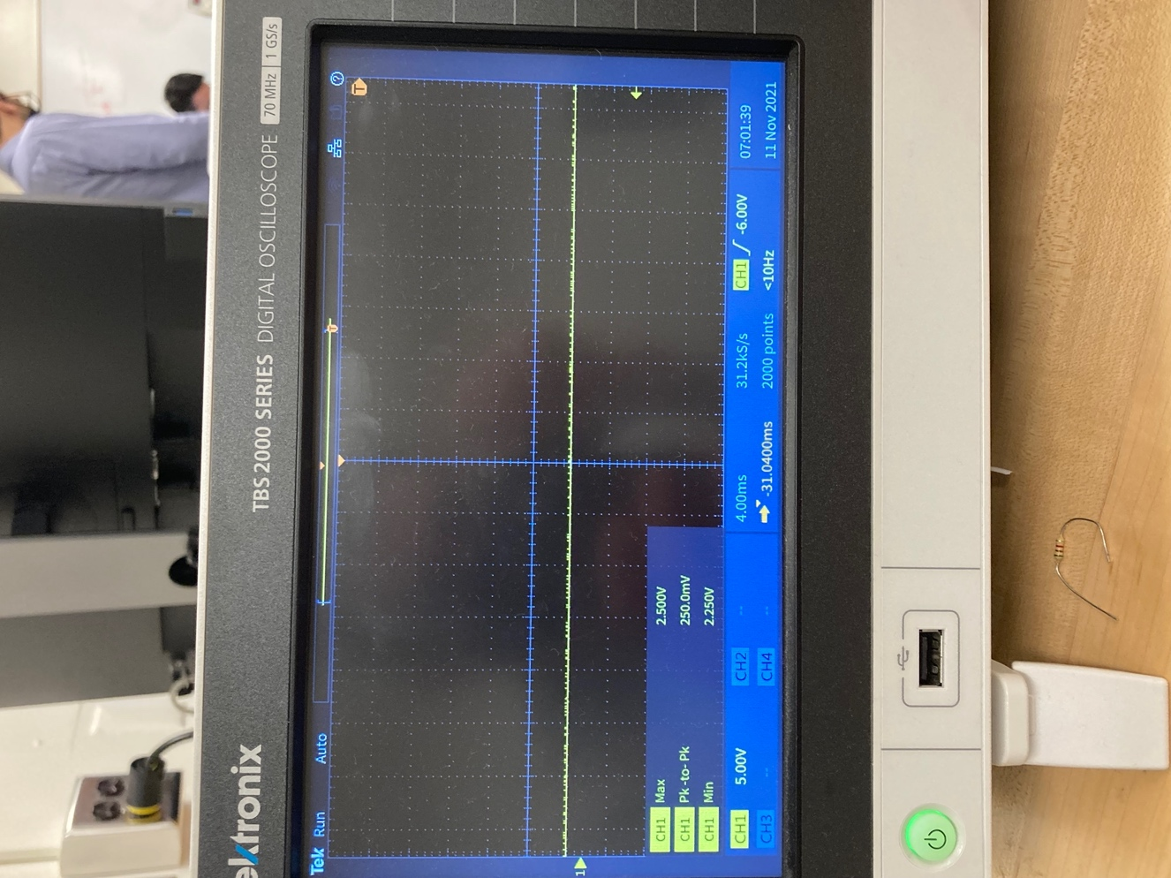

Figure 1.14 Illustrates the scope for V02 at Vin=-5V

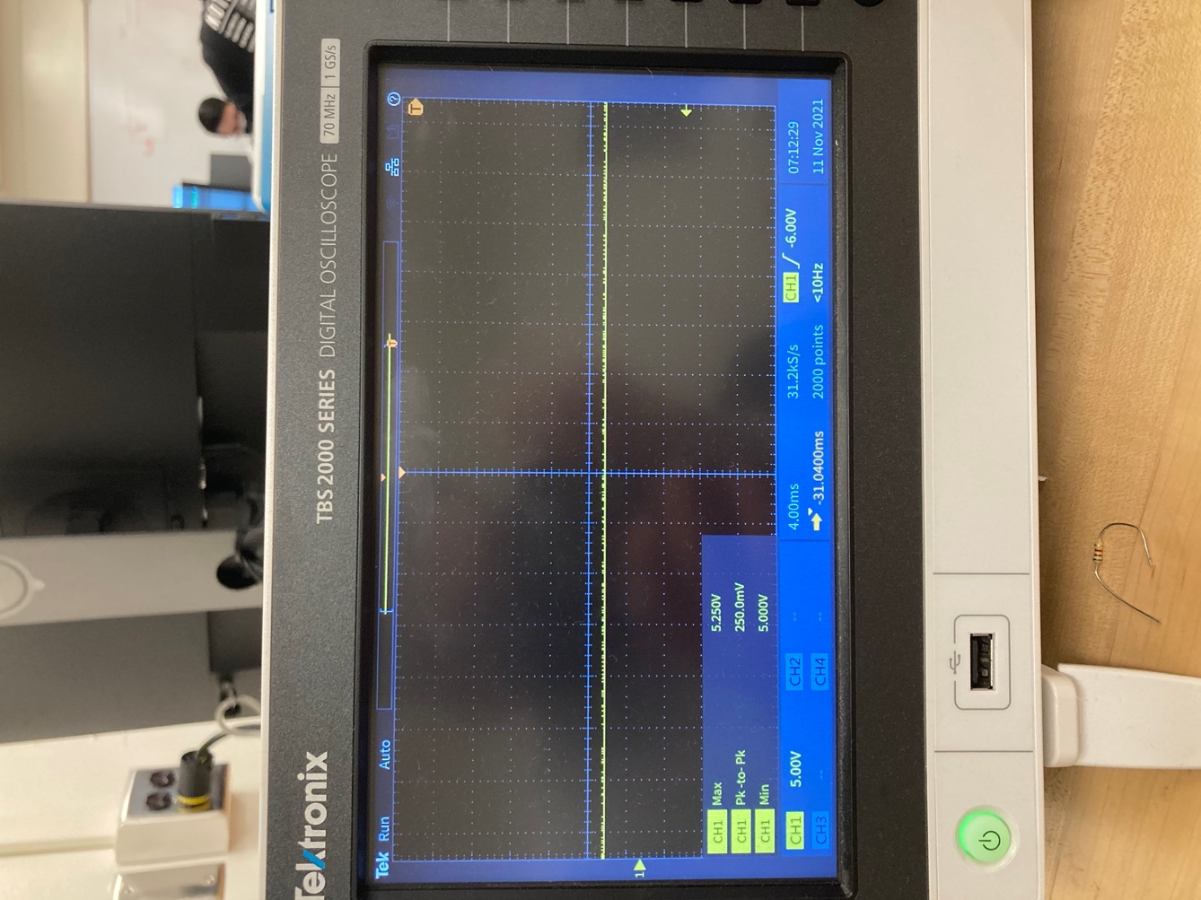

Figure 1.15 Displays the scope for V03 at Vin=5V

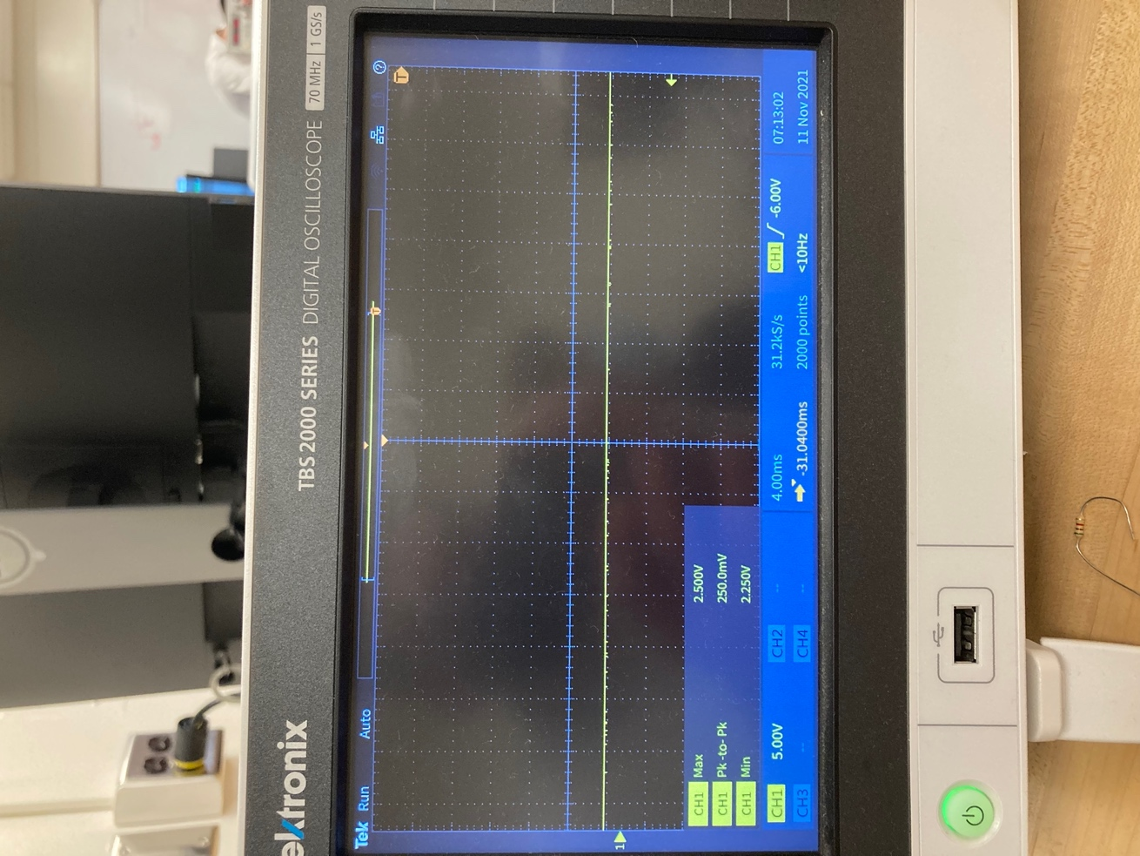

Figure 1.16 Shows the scope for V03 at Vin=0V

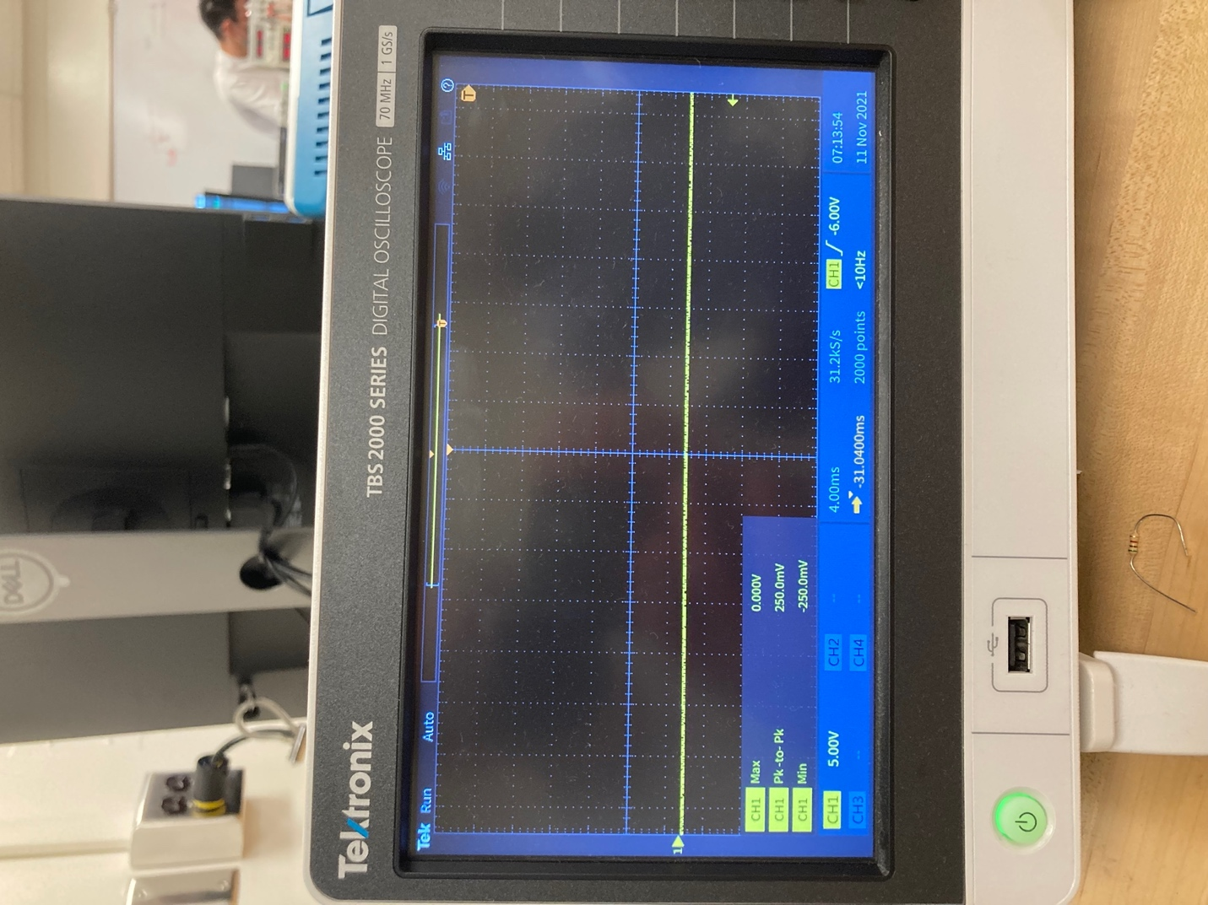

Figure 1.17 Portrays the scope for V03 at Vin=-5V

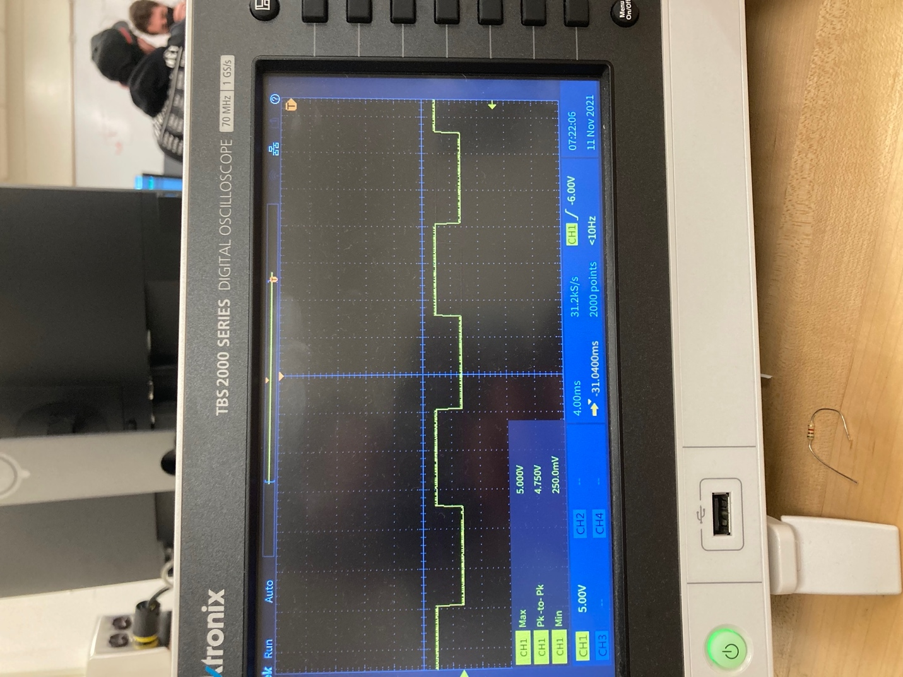

Figure 1.18 Illustrates the scope for V04 (polarity monitor)

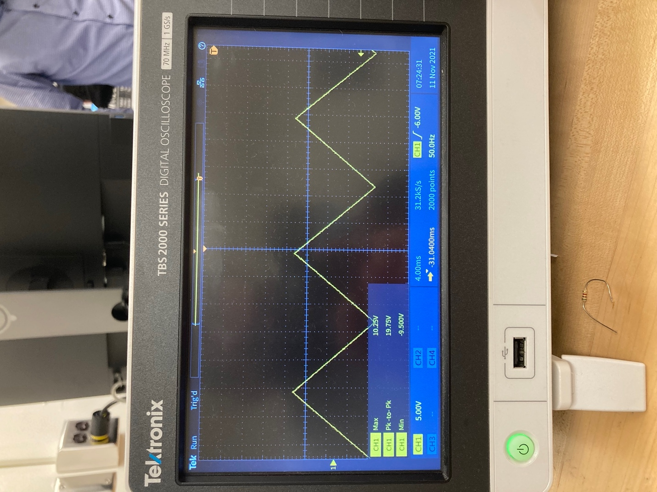

Figure 1.19 Displays the scope for Vp

**DISCUSSION**

**Error calculation**

V02 (-2) = -1.75 - -2/-2 *100 = 12.5%

V02 (2) = 2.25-2/2 *100 = 12.5%

V03(5) = 5.25-5/5 *100 = 5%

V03(2.5) = 2.5-2.5/2.5 *100 = 0%

Comparing to our previous experiments, the error was very minimal or not any error in some cases. Because for some values we obtained the max or the min values, the percent error was present. Op-amp generally reduces any chance for error. Also, we mostly used IC’s in our circuit design which are far better than NMOS and PMOS alone in terms of resulting error.

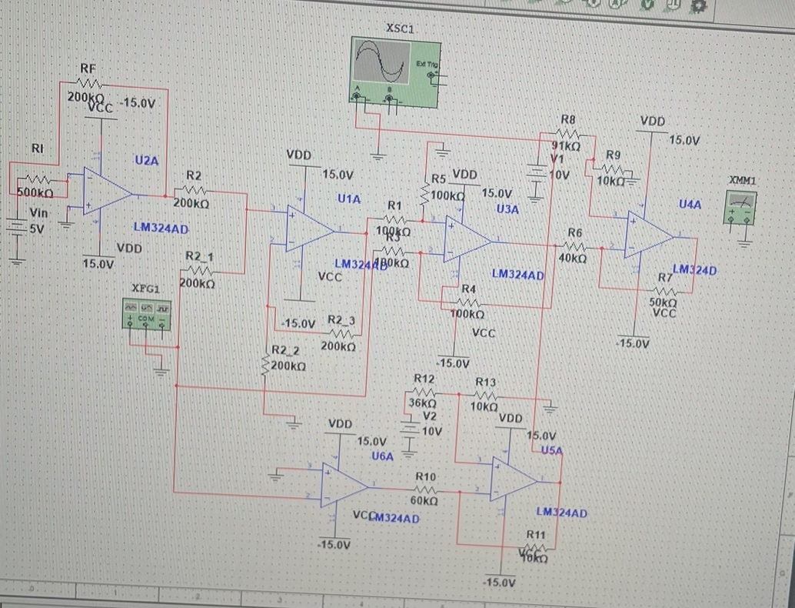

Figure 2.1 Shows the multisim simulation for the whole test circuit used in the experiment

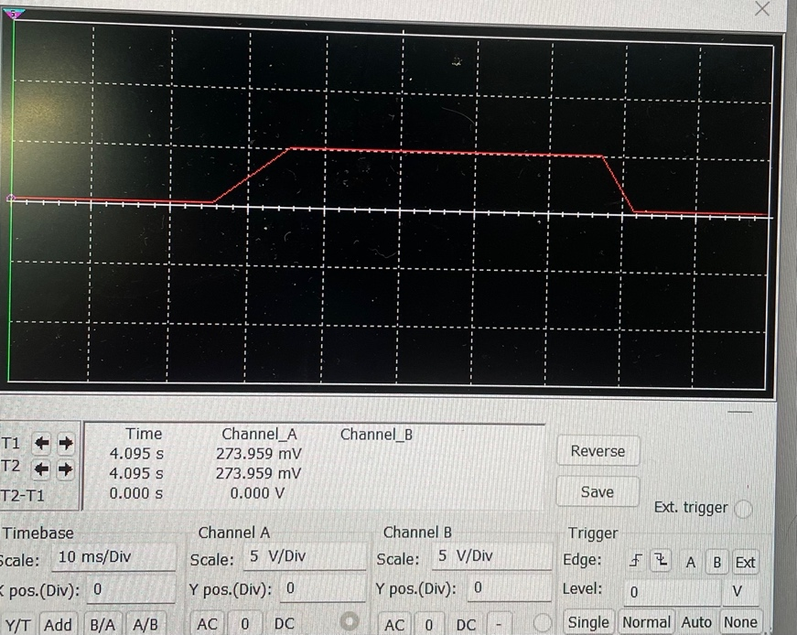

Figure 2.2 Displays the oscilloscope result of the multisim simulation

**SUMMARY AND CONCLUSION**

From this experiment on Op-Amps, we learned the key characteristics of signal conditioner, polarity monitor, difference amplifier, and transimpedance amplifier. While building the polarity monitor we realized that there were two ways to design the circuit but using the signal conditioner was more informative as the signal conditioner provides values that are then used for polarity monitor subsystem and we started with a comparator. We learned the Op-Amp LM324AD has 4 independent operational amplifiers on a single chip and that this a Low Power Quad Operational Amplifier and it has high stability, bandwidth which was designed to operate from a single power supply over a wide range of voltages.